**PROJECT REPORT**

**On**

***“AI-POWERED BY PERSONALIZED TUTOR SYSTEM”***

*Submitted for the fulfilment of the requirement for the Industrial Training by Intel Corporation.*

**

*Submitted By –*

**ATANU GUCHHAIT**

**LIST OF CONTENTS**

**1. Acknowledgment**

**2. Abstract**

**3. Introduction**

**4. Problem Statement**

**5. Proposed Solution**

**6. Methodology**

**7. System Architecture and Design**

**8. Technology Used**

**9. Testing and Results**

**10. Challenges and Limitations**

**11. Conclusion**

**12. References**

**ACKNOWLEDGMENT**

**“***We sincerely thank* ***Debdyut sir*** *for their invaluable guidance throughout the project. We also extend our gratitude to our peers and institution for their support and resources.”*

**ABSTRACT**

*The AI-powered personal tutor aims to transform traditional learning into an adaptive, student-centric experience. Using machine learning models, it predicts student assessment scores based on historical data, aiding educators in identifying learning gaps. The system makes smart promotion decisions by analyzing concept mastery. Personalized content recommendations adapt learning materials to individual student needs. Additionally, a RAG-based PDF querying system allows students to retrieve relevant information from uploaded documents efficiently. The solution also performs retention analysis to decide which content should be kept or skipped based on effectiveness. This project promotes personalized learning, enhancing student engagement and outcomes****.***

**INTRODUCTION**

*The AI-Powered Personal Tutor is an intelligent, scalable system designed to enhance student engagement by providing personalized learning experiences. Traditional educational methods often fail to address the diverse learning paces and styles of students. This project aims to leverage Artificial Intelligence to create a tutor that adapts to each student's unique needs, offering real-time feedback, customized learning paths, and interactive support. The goal is to provide students with a more engaging, effective, and personalized learning experience, making education more accessible and tailored.*

**PROBLEM STATEMENT**

**Lack of Personalization***: Traditional education systems do not cater to the diverse learning paces and styles of individual students.*

**One-Size-Fits-All Approach***: Most educational methods provide the same content and difficulty level for all students, ignoring their unique needs.*

**Student Disengagement:** *Without personalized learning experiences, students may feel disengaged or overwhelmed, which negatively impacts their motivation.*

**Inefficient Resource Utilization:** *Educators spend significant time on repetitive tasks, reducing their capacity to provide individualized support.*

**PROPOSED SOLUTION**

*Our AI-powered personal tutor aims to revolutionize education by leveraging advanced machine learning and natural language processing techniques. It predicts student assessment scores based on past performance, enabling educators to identify learning gaps early. The system also makes smart promotion decisions, determining whether a student is ready to advance based on their mastery of concepts. To enhance learning, it offers personalized content recommendations, tailoring study materials to each student's level and progress. Additionally, a PDF querying system, powered by a RAG-based pipeline, allows students to efficiently extract relevant information from uploaded documents. Lastly, the solution performs retention analysis, identifying which content should be kept or skipped based on student-level performance data and material effectiveness. This holistic approach promotes adaptive learning, making education more personalized and effective.*

**METHODOLOGY**

***Data Collection and Preprocessing:***

* *Describe the dataset used for assessment score prediction (e.g., student grades, assessments).*
* *Mention preprocessing steps: handling missing values, scaling, or encoding.*

***Machine Learning Models Used:***

* ***Assessment Prediction:***
  + *Model used (e.g., Random Forest, XGBoost).*
  + *Training and testing split.*
  + *Evaluation metrics (accuracy, precision, recall).*
* ***Promotion Decision:***
  + *Rules or classification models for determining promotion.*
* ***Content Recommendation:***
  + *Collaborative filtering or content-based filtering model.*
* ***PDF Querying (RAG pipeline):***
  + *Use of FAISS or Chroma for embedding storage.*
  + *Language model.*
* ***Retention Analysis:***
  + *Identify less effective content using performance metrics.*

**SYSTEM ARCHITECTURE AND DESIGN**

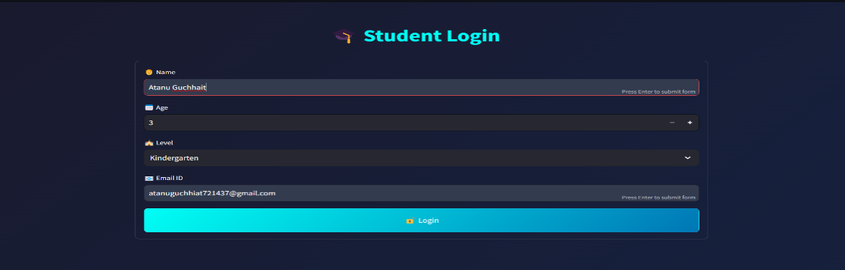



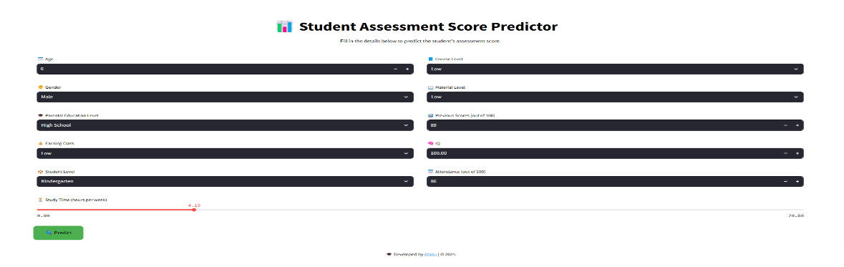

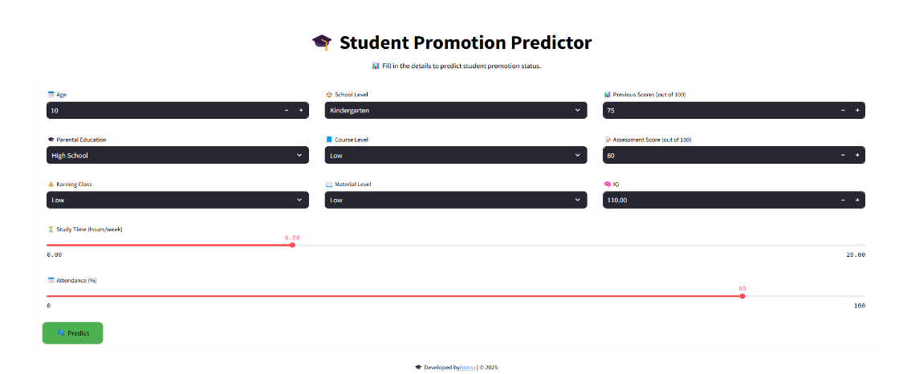

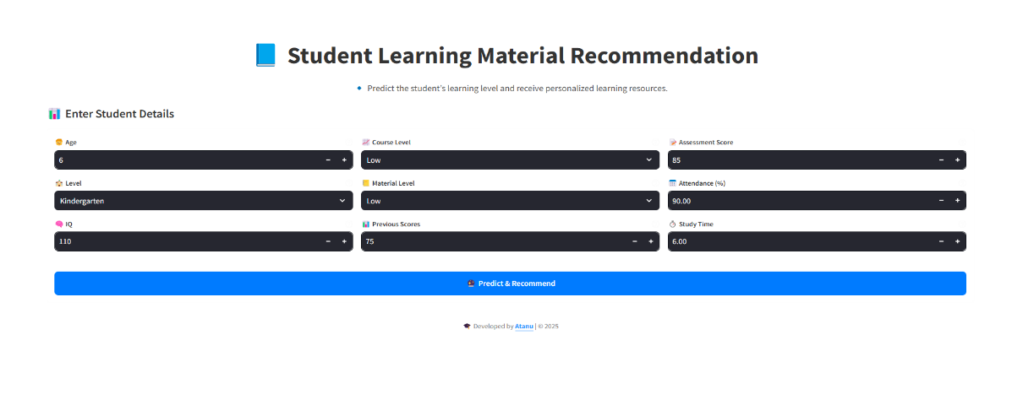

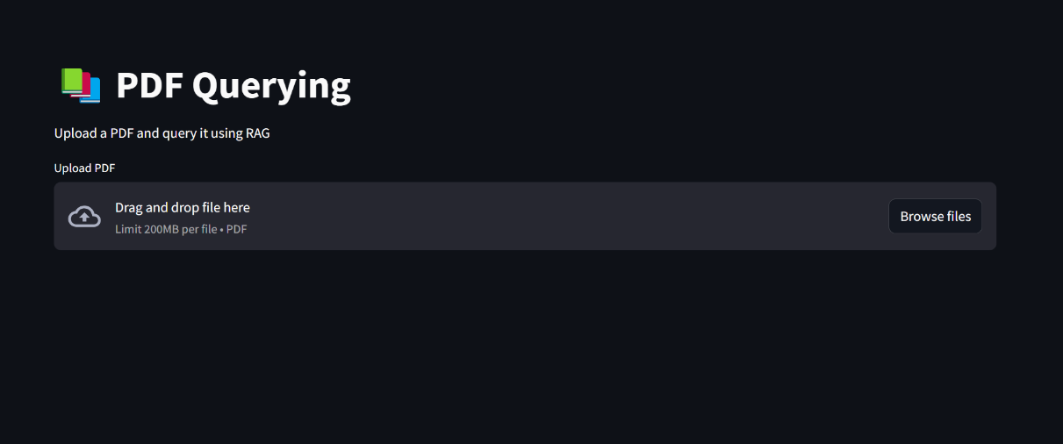

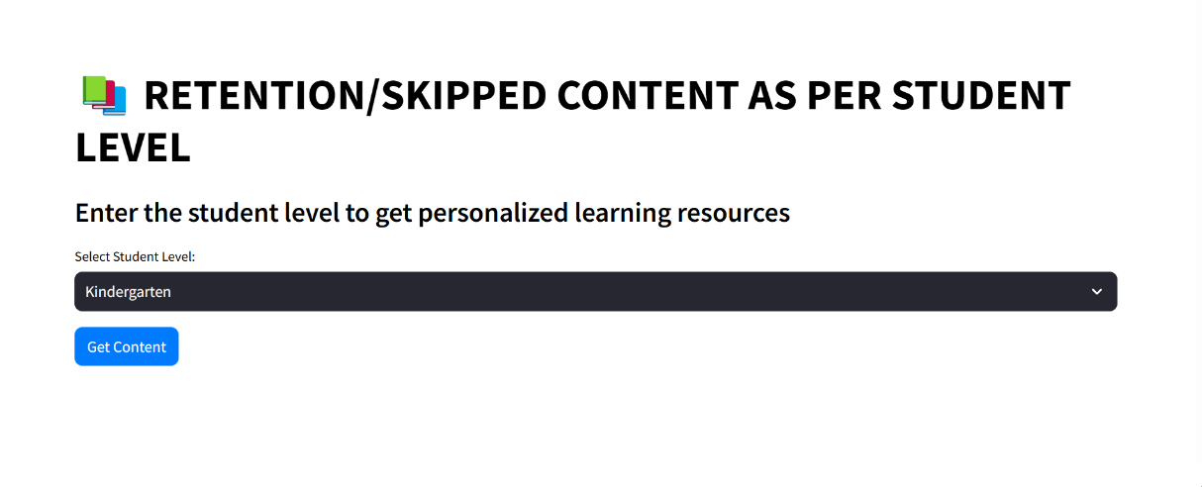

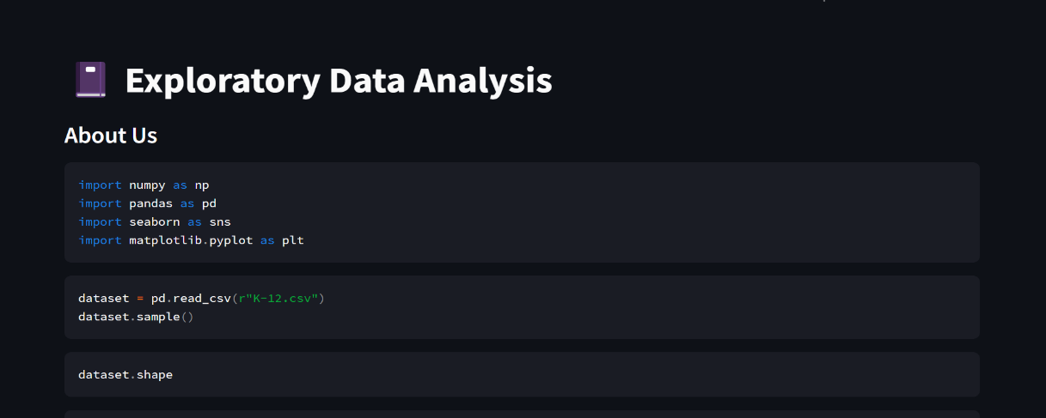

**TECHNOLOGY USED**

**Data Manipulation and Analysis:** *Numpy, Pandas for Pre-processing*.

**Data Visualization :** *Matplotlib, Seaborn For visualization.*

**Machine Learning (ML)**: *Scikit-learn, Pickle, Column Transformer, Scikit-learn Pipeline.*

**Natural Language Processing (NLP)**: *For intelligent interaction with students, enabling them to ask questions and receive explanations in natural language.*

**Rag-Pipeline *:*** *For PDF Query.*

**Streamlit/HTML/CSS**: *For building interactive and user-friendly web interfaces for both students and educators.*

**TESTING AND RESULT**

* **Student Promotion Prediction**
* ***Model*:** *RandomForestClassifier*
* ***Metrics****: Accuracy Score, Confusion Matrix*
* ***Results****: 99.99% accuracy score, ensuring high-quality recommendations.*
* **Content Recommendation**
* ***Model****: Softmax Regression*
* ***Metrics****: Accuracy Score, Confusion Matrix*
* ***Results****: 100% accurate in Content Recommendation.*
* **Assesment Score Prediction**
* ***Model****: RandomForestRegressor*
* ***Metrics****: Mean squared error, r2score*
* ***Results****: MSE : 0.0008, r2score : 100%*

**Content Retention/Skipping**

* ***Model****: xgbClassifier*
* ***Metrics****: Accuracy Score, Confusion Matrix*
* ***Results****: 100% Accuracy score.*

**CHALLENGES AND LIMITATIONS**

* **Data Quality & Availability**
* *Inconsistent or insufficient data can affect recommendation accuracy. Requires large, high-quality datasets for effective learning.*
* **Computational Requirements**
* *High processing power needed for AI models, especially NLP-based components. Real-time response optimization for smooth user experience.*
* **Integration with External Platforms**
* *Difficulty in integrating with job portals, course providers, and learning platforms. API limitations and changing platform policies.*
* **PDF Query accuracy**
* *Ensuring generated answer are meaningful and not overly simple or complex.*
* *May require human validation for high-stakes assessments.*

**CONCLUSION**

* *The AI-Powered Personal Tutor effectively enhances learning through personalized recommendations, PDF Query, Student Promotion and Assesment Score Prediction,. Despite challenges like data quality, model bias, and computational requirements, the system demonstrates high accuracy, engagement, and scalability. Future improvements will focus on refining AI models, ensuring fairness, and enhancing user experience to create a truly adaptive learning platform.*

**REFERENCES**

***CampusX :*** *Educational content, machine learning resources, and practical implementation guidance. Retrieved from* [*https://www.campusx.in*](https://www.campusx.in/)

***Deepseek AI :*** *AI-powered solutions and model assistance. Retrieved from* [*https://www.deepseek.com*](https://www.deepseek.com/)

***OpenAI. (2025). ChatGPT:*** *A conversational AI. Retrieved from* [*https://www.openai.com/chatgpt*](https://www.openai.com/chatgpt)